Raspberry Pi – Netflix Project

Objective: Configure Kodi media player on Raspberry Pi to enable it to stream shows/movies on Netflix, directly on your Pi.

# Step 1: Configure Your Pi

Use the commands “sudo apt-get update” and then “sudo apt-get upgrade” to download and install software updates for your raspberry pi.

Next, you need to install Kodi, a media player program that is available on raspberry pi, as well as some additional packages to make sure that Kodi and its Netflix plugin work properly. Then you will also have to download the Netflix plugin separately from GitHub, as shown below:

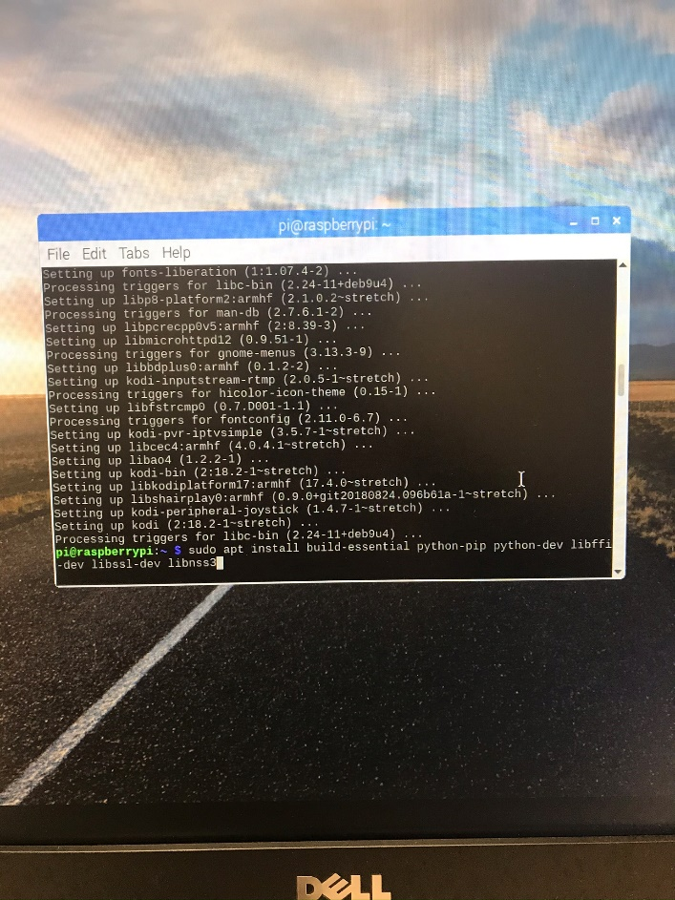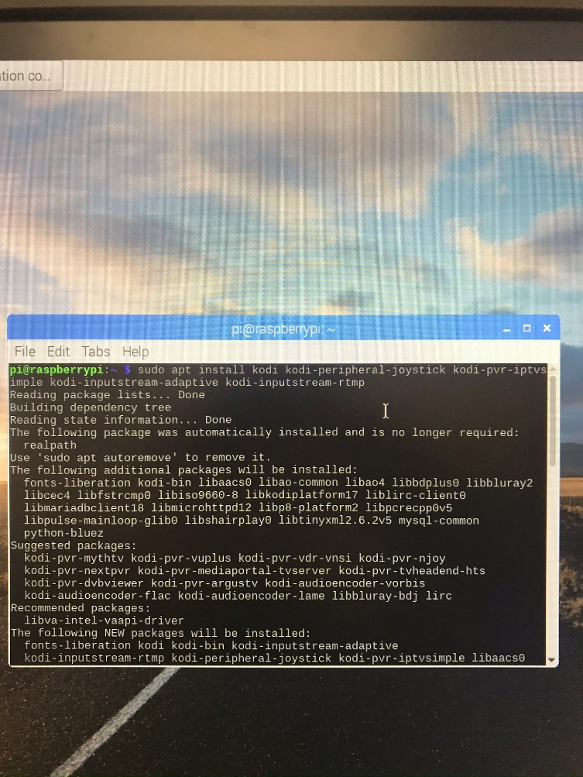

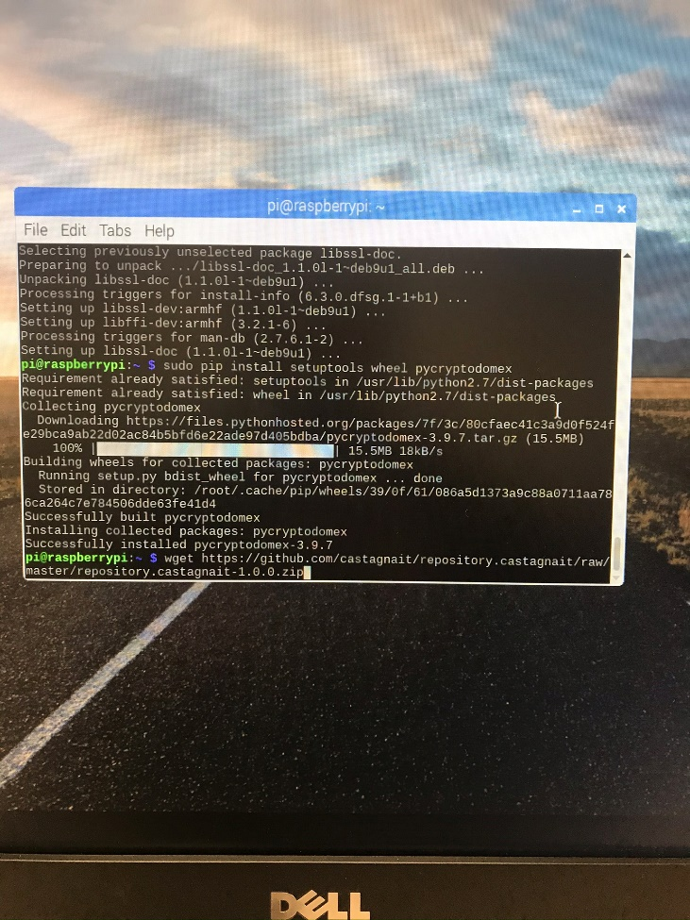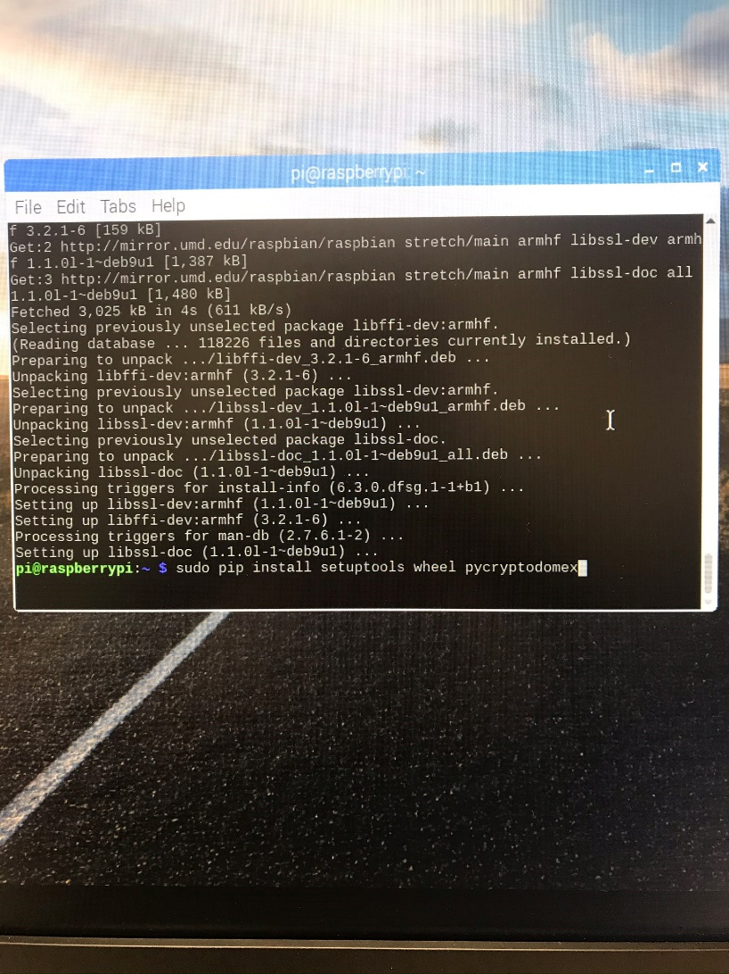

## Step 2: Open and Configure Kodi

Go to the start menu on your Pi and click videos and media, then click Kodi to open it. You will then have to change your system settings to allow add-ons from unknown sources. Once it is enabled, you will have to install the Netflix from the CastagnaIt repository( the .zip file you downloaded from GitHub). Then, you will have to enable InputStream Adaptive in the VideoPlayer Add-ons settings.

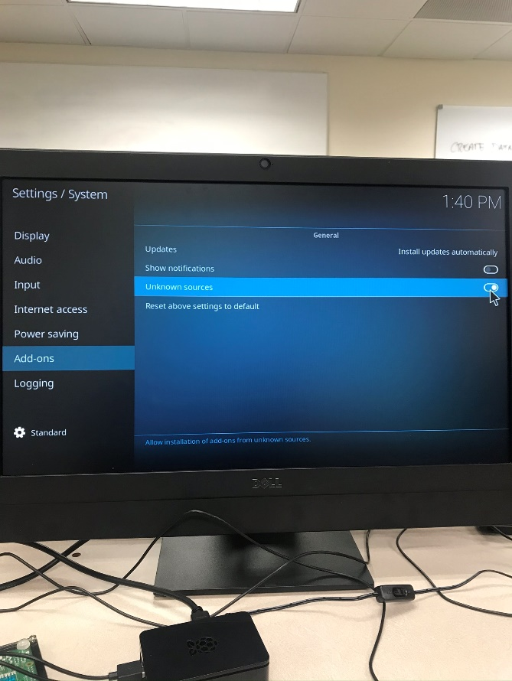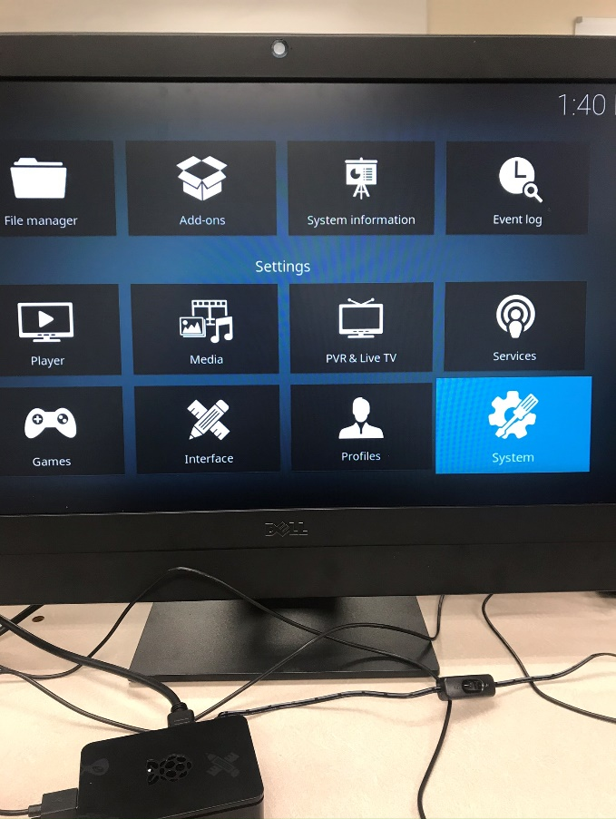

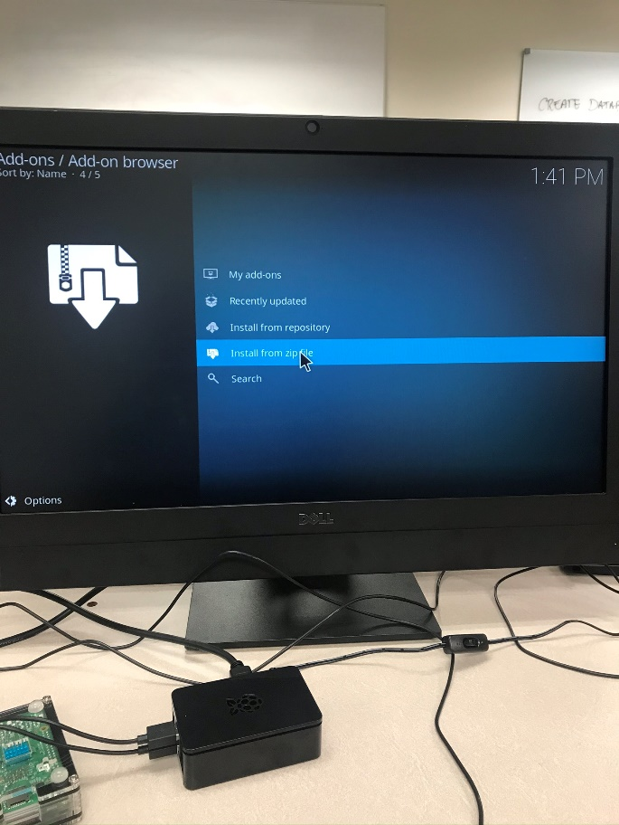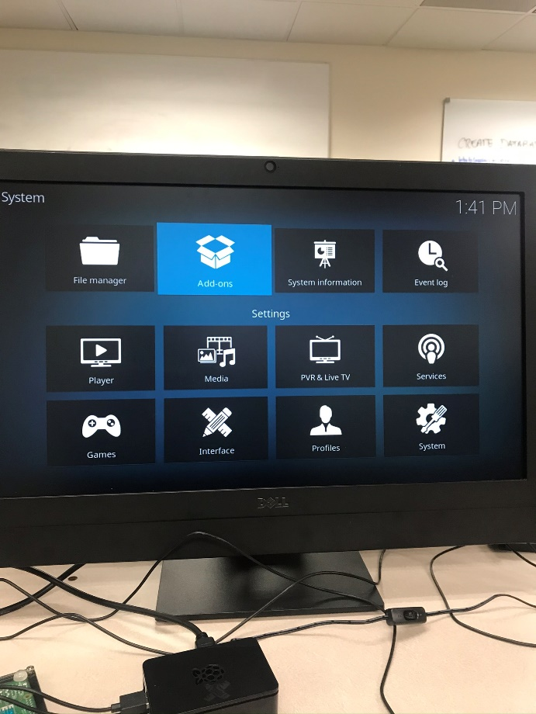

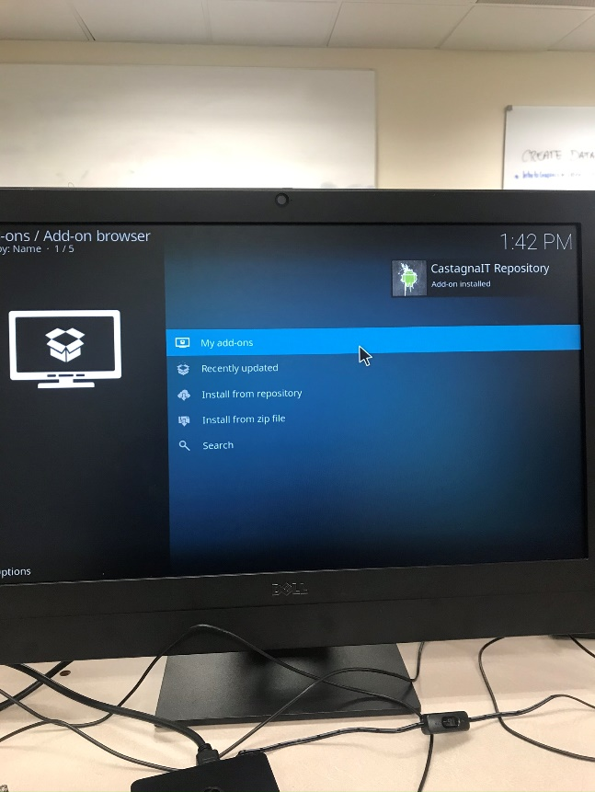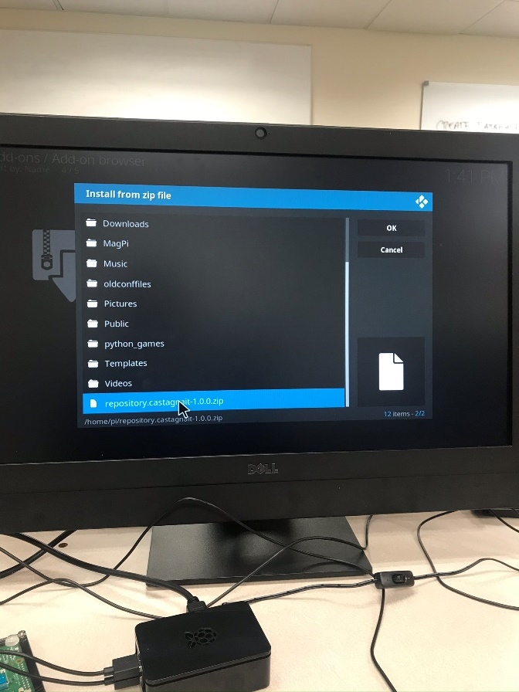

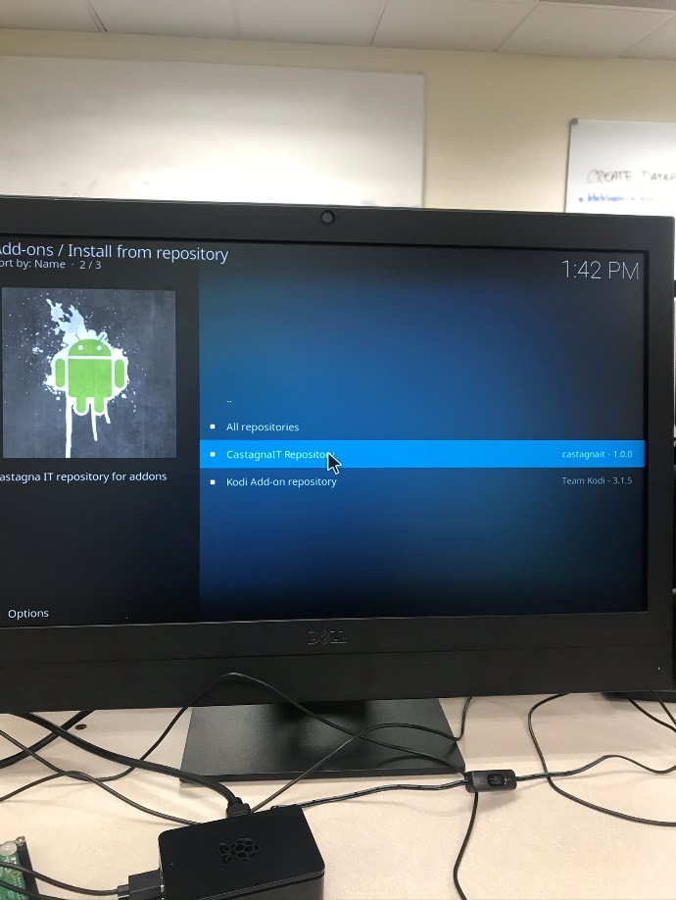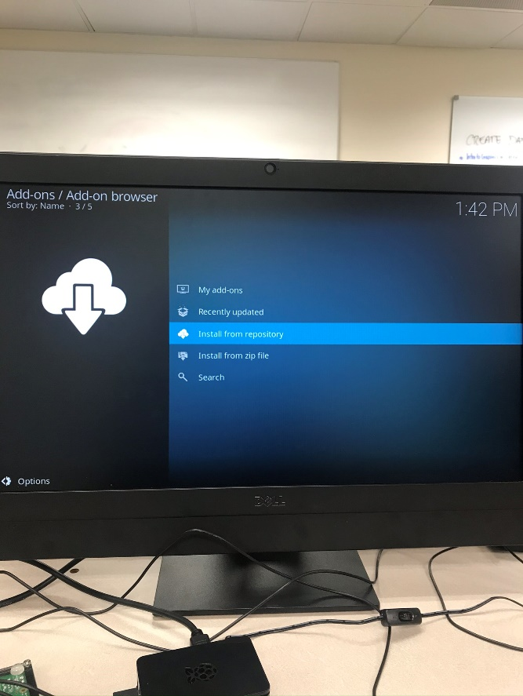

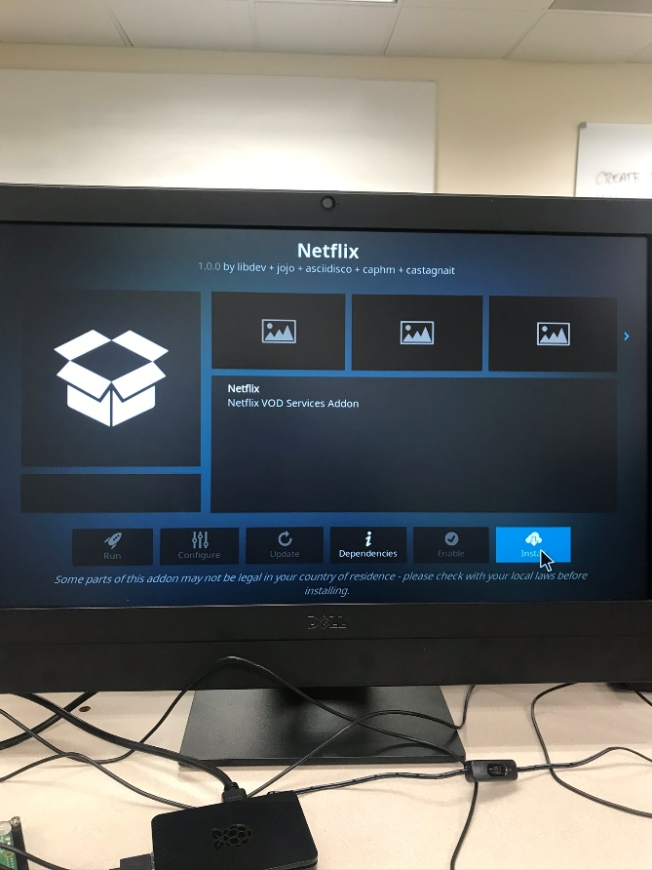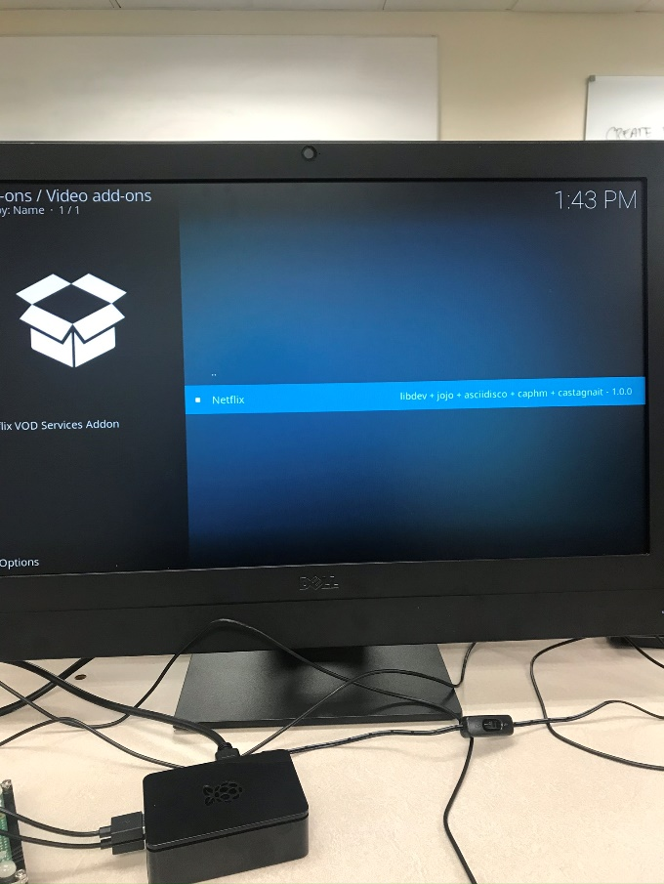

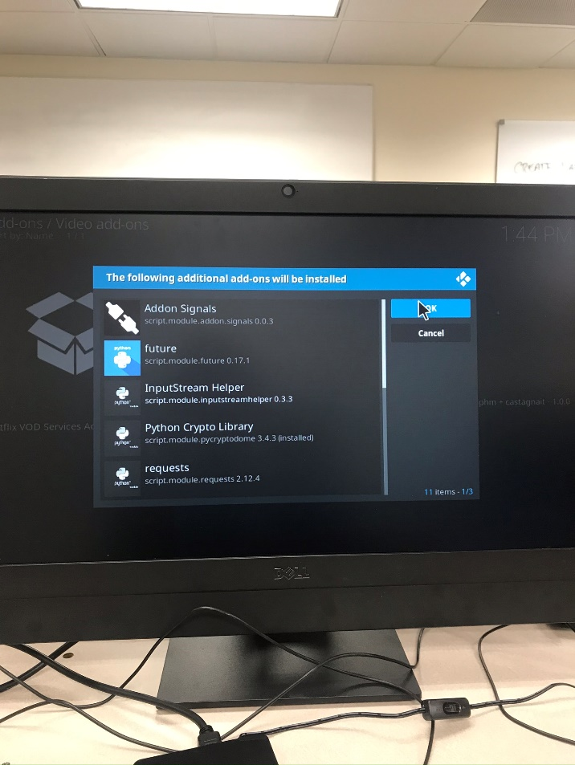

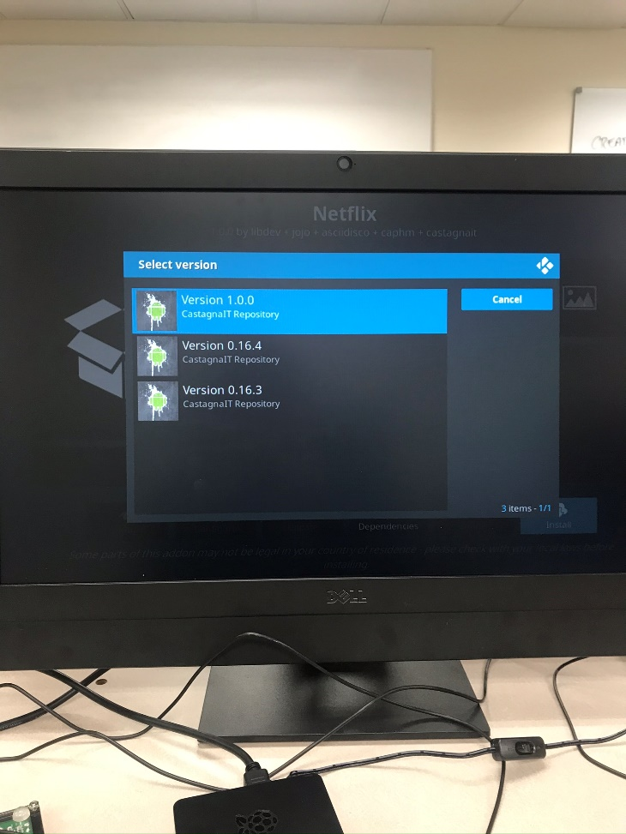

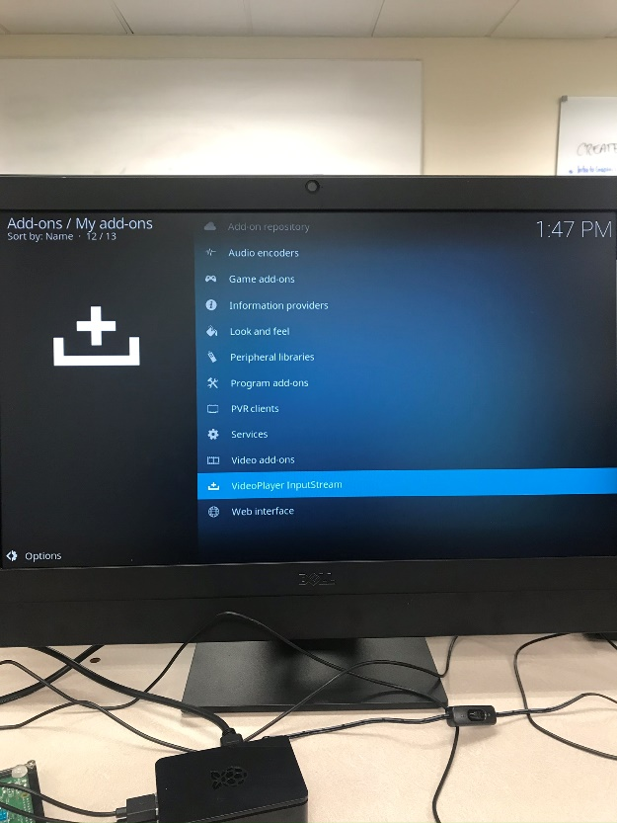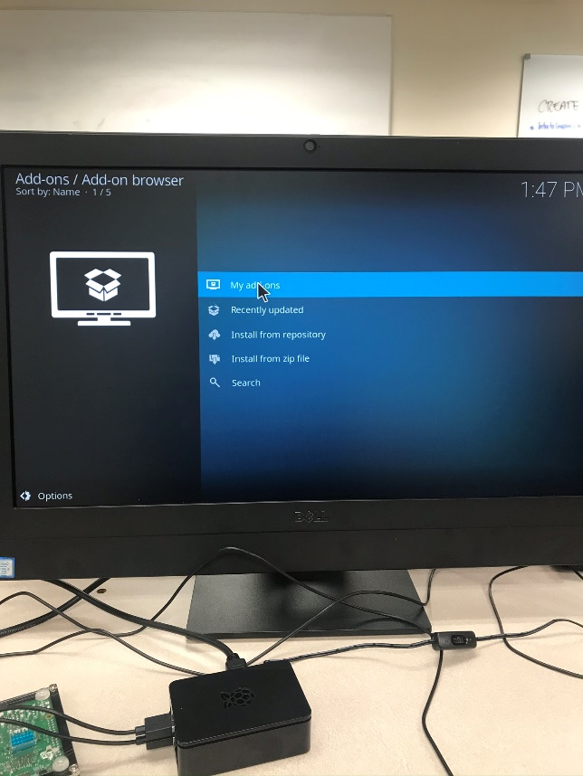

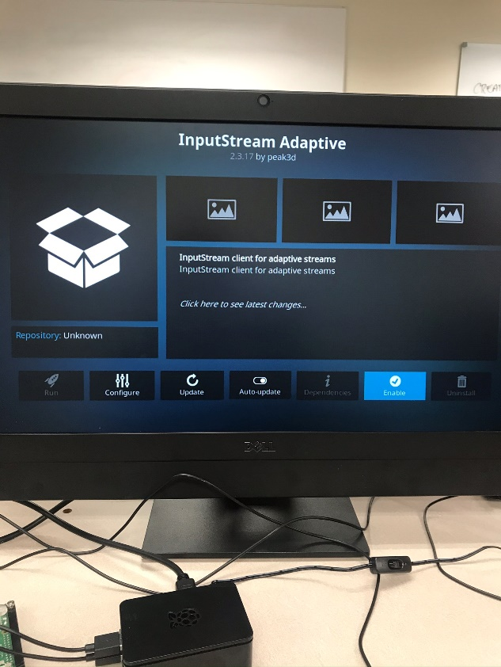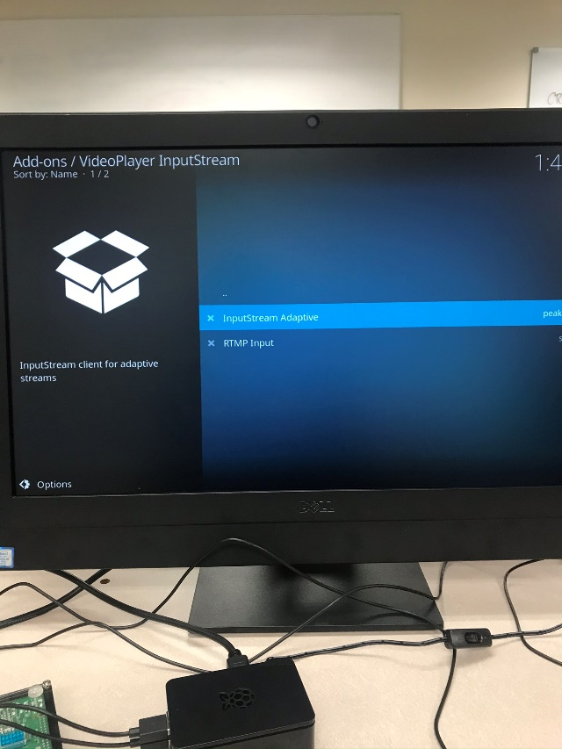

## Step 3: Setup Netflix and Enjoy

Now you can open up your Netflix plugin and log-in. But wait, you’re still not ready to watch your favorite shows/movies quite yet. Once you select a show to watch, it is going to ask you to install the Widevine CDM media decryption module; just click install. Then click yes when it prompts you about the space requirements, and agree to the EULA software agreement. Once the download and extraction is complete, you are ready to binge.

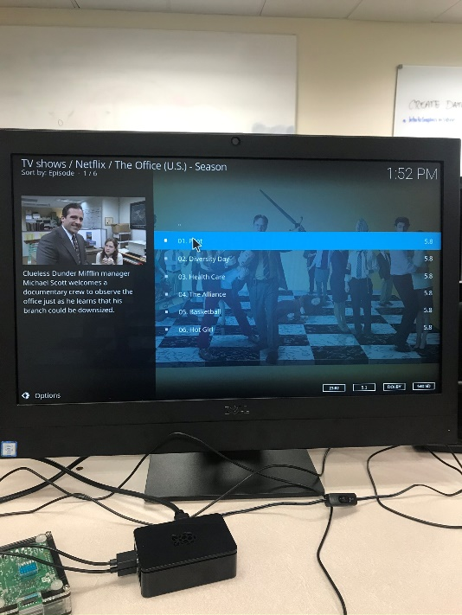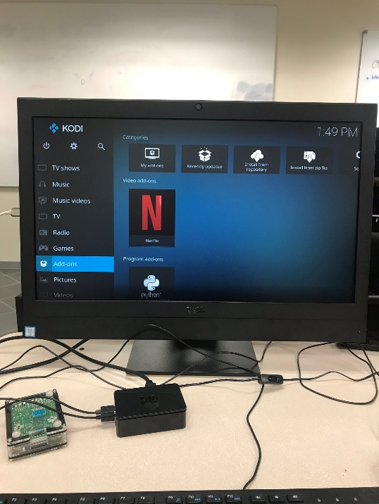

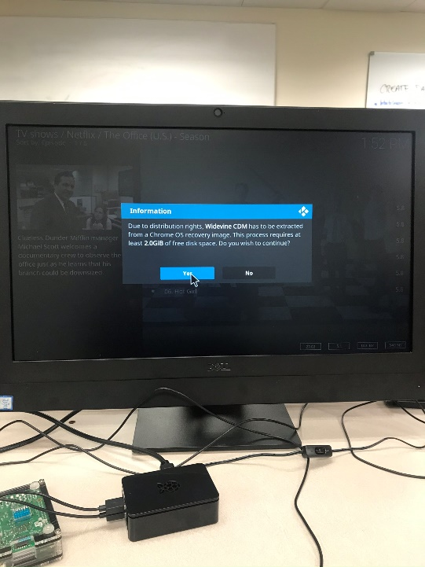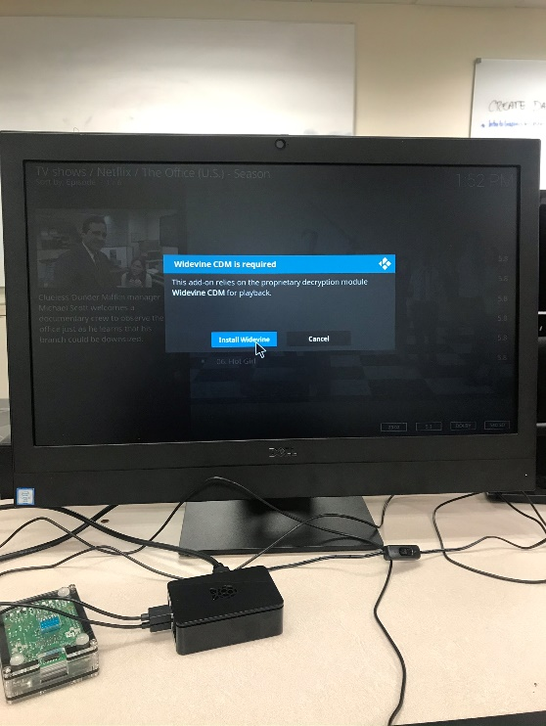

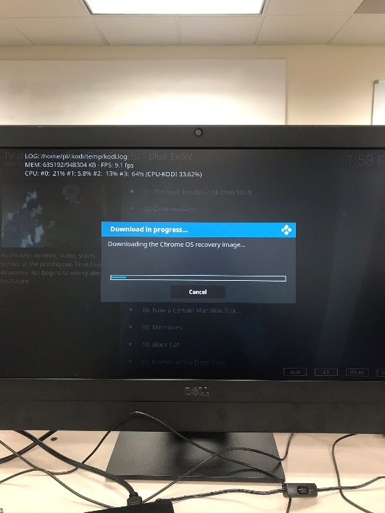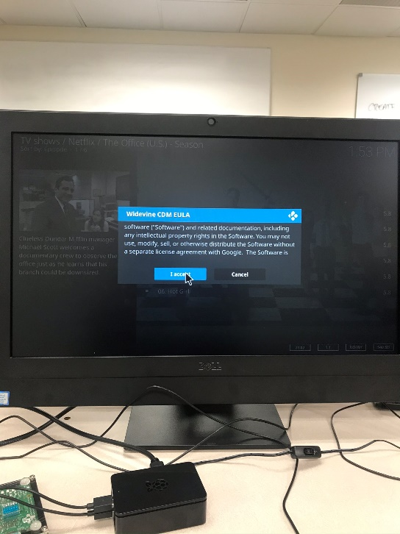C

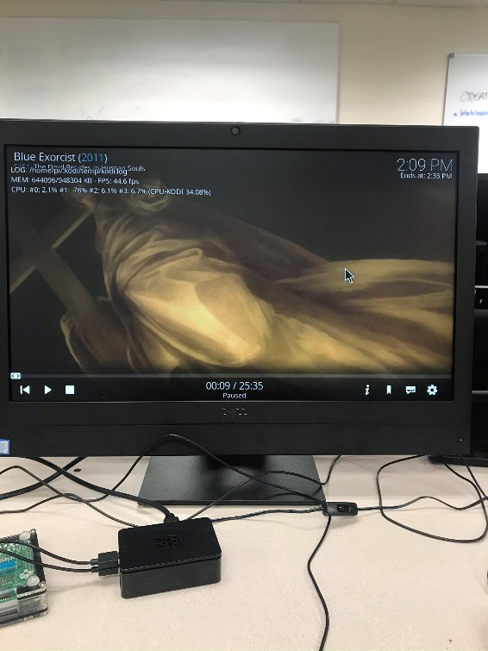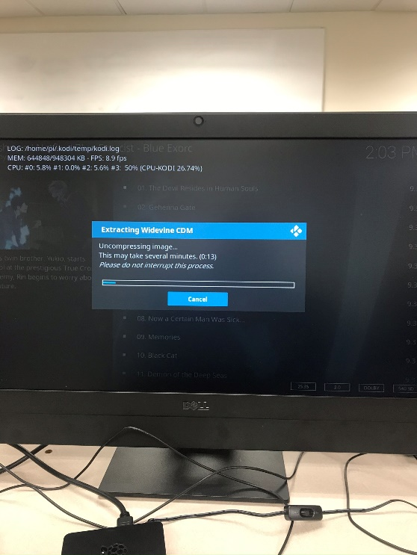

## Challenges/ Difficulties

Some update that I did caused my raspberry pi to be unable to connect to the desktop, and while I tried a couple things that I thought might be quick fixes, it was became apparent that I needed to re-install my system. In the meantime, I borrowed another raspberry pi to complete this project on.

Other than a few updates taking a rather long time, this project went quite smoothly. The only hiccup was the first time I tried to download the Widevine CDM, it failed for an unknown reason. To try to solve it, I went into the Kodi System settings, and turned on error-logging. I restarted Netflix and tried it another show. It took a few minutes, but it downloaded correctly the second time, and I was able to watch the show.